Introduction

The Project is called ‘B+ devices ‘ and is based on use of Bluetooth .This intents at transferring data from one device to many[two atleast]. To provide this simultaneous exchange of data using Bluetooth viz. a Peer to Peer configuration , we have suggested a solution.
Our project uses Record Management of devices . With a couple of mobile enabled with our application ,any of the interested device can approach others to join in [Limited to at most two in our case]. The parent or originator device shall keep a Record of Active connections and information about child mobile should be saved for this active session.

- For simultaneous interaction between devices , we can use Record of devices, i.e we can Time slice and then provide each mobile with its share of Bluetooth connectivity slice. And then we switch to the other while saving the state and status of the Previous connection.
Thus this gives an appearance of simultaneous Interaction.

- To Counter the limited Data Transfer rate we thought of a Heuristic technique , wherein each parent device can make say. atmost two connections to child devices. While these two child can further connect to two devices and so on. Thus forming a Binary Tree. The advantage of this approach is that it takes away from a single device the burden to handle multiple devices and evenly distributes it to n-[2*lg₂n] devices.

BLUETOOTH

The major features of Bluetooth are:
- Bluetooth is wireless and automatic. You don't have to keep track of cables, connectors, and connections, and you don't need to do anything special to initiate communications. Devices find each other automatically and start conversing without user input, expect where authentication is required; for example, users must log in to use their email accounts.
- Bluetooth is inexpensive. Market analysts peg the cost to incorporate Bluetooth technology into a PDA, cell phone, or other product at around $20 now, and say that it could fall to as little as $5 per unit.
- The ISM band that Bluetooth uses is regulated, but unlicensed. Governments have converged on a single standard, so it's possible to use the same devices virtually wherever you travel, and you don't need to obtain legal permission in advance to begin using the technology.
- Bluetooth handles both data and voice. Its ability to handle both kinds of transmissions simultaneously makes possible such innovations as a mobile hands-free headset for voice with applications that print to fax, and that synchronize the address books on your PDA, your laptop, and your cell phone.
- Signals are omni-directional and can pass through walls and briefcases. Communicating devices don't need to be aligned and don't need an unobstructed line of sight.
- Bluetooth uses frequency hopping. Its spread spectrum approach greatly reduces the risk that communications will be intercepted.

Architecture of J2ME CDLC/MIDP and Bluetooth

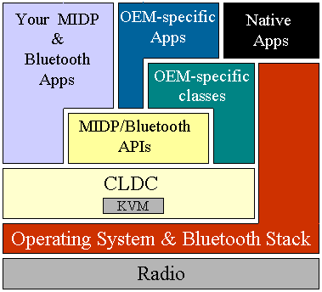
fig:-High-level Architecture of J2ME CDLC/MIDP and Bluetooth

The APIs are designed in such a way that developers can use the Java programming language to build new Bluetooth profiles on top of this API as long as the core layer specification does not change. To promote this flexibility and extensibility, the specification is not restricted to APIs that implement Bluetooth profiles. JSR 82 includes APIs for OBEX and L2CAP so that future Bluetooth profiles can be implemented in Java, and these are already being used for that purpose. Figure shows where the APIs defined in this specification fit in a CLDC/MIDP architecture.

A small computing device has two components supplied by the Original Equipment Manufacturer (OEM). These are classes and applications. OEM classes are used by MIDP to access device-specific features such as sending and receiving messages and accessing device-specific persistent data.

Feasibility study

Technology and System feasibility
This feasibility deals with whether a project’s technology requisites are feasible. Our project requires Java and bluetooth enabled devices. Most of the multimedia phones are java enabled and Bluetooth is a common technology developed for data transfer. All the technology for this project’s composition is easily avialable. The simultaneous data transfer approach we have used is also practical with a few implications.The applications require some minimum configurations of both volatile and non volatile memory such as, 32 Kb space to run JVM , such requiste are easily available in most devices. The applications written are usually Platform independent.

Economic feasibility
This is done to evaluate the effectiveness of a new system. The Cost benfit Analysis [CBA] shows that the Input and effort to Project yield very fruitful outcomes. The cost involved in development is controlled and very much economical ,since it only requires bluetooth and Wireless Toolkit. The Sun Java Wireless Toolkit is easily available at sun microsystem’s Website and is free of charge.
All we need to think about is mobile phones to be used . For the simplest case we can take cellphones of same make and feature(such as Display). We need utmost three mobiles to meet our purpose.To add to this the prices of Java Enabled mobiles are falling every month ,so its not a big headache.

Schedule feasibility
The Project is bound to complete within given scheduled time. We’ve been provided with an year’s time to build up this project which is sufficient to learn and develop applications. The basic functioning can be developed which can later be changed as per user’s requirement. Our group of four people have equally divided thew work amongst each other. We are using JAVA WIRELESS TOOLKIT and have been provided with all required APIs.

Operational Feasibiltiy
The project is operationally feasible and can satisfy all GUI and processing requirement. Though the operations performed on mobiles is limited by memory size and slow processing rate ,but stilll quite a few User interactive applications have been built already. Users often demand for high interactivity , clear graphics ,faster speed etc as requirement. All these will be countered easily by our application , except for the ‘Speed’ portion .The jar file can be made available to the Users (as free Internet Download) and the user can easily transfer and deploy the files to their system. The application will require minimum User Input for setting up . If user’s Device doesn’t satisfies the Threshold Configuration criteria the application would simply give error messages at Installation Time itself and the Setup won’t continue.

Emulator:: The Development Environment for our MIDLET

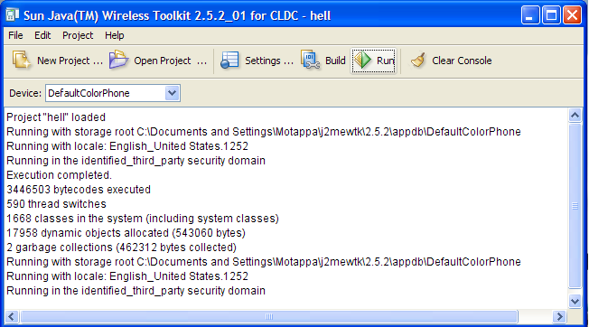

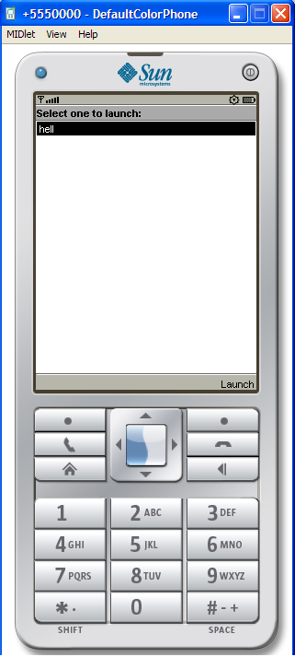

Hardware and Software Requirements

Hardware:
- 8 KB Non Volatile memory for persistent storage.
- 128 KB Non Volatile memory to run Mobile Information Device (MID)
- 32 KB Volatile memory to run JVM( KJVM)
- Device must have 96 x 54 pixel display to handle Bitmapped Graphics
- Must have Input device such as keyboard, keypad ,touch screen.
- JAVA enabled Mobile Device

Software:
- Java Virtual Machine(KJVM)
- MIDP that contains Java APIs for user connections, Storage, User Interface
- Native Operating system of device.

Bibliography

- Complete Reference J2ME by James Keogh
- Wireless Toolkit Sun Java Examples
- www.wikkipedia.com
- Bluetooth Information from Qusay H. Mahmoud

